**Edwest Examination**

**Semester 2, 2017**

**Question/Answer booklet**

**HUMAN**

**BIOLOGY**

**Unit 1&2**

|  |  |  |  |  |  |  |  |
| --- | --- | --- | --- | --- | --- | --- | --- |
|  |  |  |  |  |  |  |  |

Student number: In figures

In words ______________________________

______________________________

**Time allowed for this paper**

Reading time before commencing work: ten minutes

Working time: three hours

**Materials required/recommended for this paper**

***To be provided by the supervisor***

This Question/Answer booklet

Multiple-choice answer sheet

***To be provided by the candidate***

Standard items: pens (blue/black preferred), pencils (including coloured), sharpener, eraser, correction fluid/tape, ruler, highlighters

Special items: non-programmable calculators approved for the use in this examination

**Important note to candidates**

No other items may be taken into the examination room. It is **your** responsibility

to ensure that you do not have any unauthorised notes or other items of a non-

personal nature in the examination room. If you have any unauthorised material with

you, hand it to the supervisor **before** reading any further.

**Structure of this paper**

|  |  |  |  |  |  |
| --- | --- | --- | --- | --- | --- |
| **Section** | **Number of questions available** | **Number of questions to be answered** | **Suggested working time**  **(minutes)** | **Marks available** | **Percentage of examination** |
| **Section One:**  **Multiple-choice** | 30 | 30 | 40 | 30 | 30 |
| **Section Two:**  **Short answer** | 10 | 10 | 90 | 100 | 50 |
| **Section Three:**  **Extended answer** | 4 | 2 | 50 | 40 | 20 |
|  | | | | | 100 |

**Instructions to candidates**

1. The rules for the conduct of the Western Australian Certificate of Education ATAR course examinations are detailed in the Year 11 Information Handbook 2017. Sitting this examination implies that you agree to abide by these rules.
2. **Answer the questions according to the following instructions.**

Section One: Answer all questions on the separate Multiple-choice answer sheet provided. For each question, shade the box to indicate your answer. Use only a blue or black pen to shade the boxes. If you make a mistake, place a cross through that square then shade your new answer. Do no erase or use correction fluid/tape. Marks will not be deducted for incorrect answers. No marks will be given if more than one answer is completed for any question.

Section Two: Write your answers in this Question/Answer booklet. Whenever possible, confine your answers to the line spaces provided.

Section Three: Consists of three questions. You must answer two questions.

Tick the box next to the question you are answering.

1. You must be careful to confine your answers to the specific questions asked and to follow any instructions that are specific to a particular question.
2. Additional working space pages at the end of this Question/Answer booklet are for planning or continuing an answer. If you use these pages, indicate at the original answer, the page number it is planned/continued on and write the question number being planned/continued on the additional working space page.

**Section One: Multiple- choice 30% (30 Marks)**

This section has **30** questions. Answer **all** questions on the separate Multiple-choice answer sheet provided. For each question, shade the box to indicate your answer. Use only a blue or black pen to shade the boxes. If you make a mistake, place a box through that square then shade your new answer. Do not erase or use correction fluid/tape. No marks will be given if more than one answer is completed for any question.

Suggested working time: 40 minutes.

___________________________________________________________________

1. Which of the following objects has the greatest surface area to volume ratio?

(a) 1000 μm cube of potato

(b) 600 μm cube of potato

(c) 200 μm cube of potato

(d) 1mm cube of potato

2. Which of the following is an example of a connective tissue?

(a) Outer layer of skin

(b) Fat stored under the skin

(c) Iris of the eye

(d) Brain and spinal cord

3. The production of ATP from a molecule of glucose is an example of

(a) anabolism of an organic molecule.

(b) anabolism of an inorganic molecule.

(c) catabolism of an organic molecule.

(d) catabolism of an inorganic molecule.

4. Proteins consist of small molecules called

(a) fatty acids.

(b) glycerol.

(c) nucleotides.

(d) amino acids.

5. Enzymes

(a) lower activation energy.

(b) are used up during chemical reactions.

(c) are specific to one product.

(d) all of the above.

6. Which of the following dysfunctions of the respiratory system can be described as ‘loss of elasticity to the alveoli’ and ‘decrease in surface area of the lungs’?

(a) Asthma

(b) Pneumonia

(c) Lung cancer

(d) Emphysema

The next two questions refer to the diagram below.

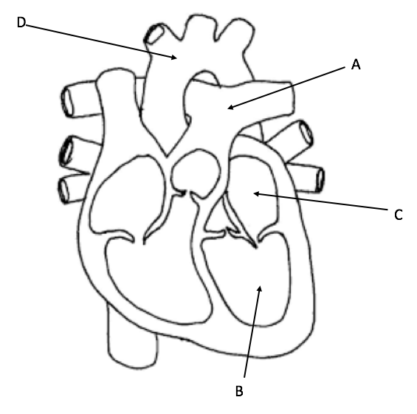

7. Which label correctly identifies the structure that transports deoxygenated blood to the lungs?

(a) A

(b) B

(c) C

(d) D

8. Which label correctly identifies the structure that receives oxygenated blood from the lungs?

(a) A

(b) B

(c) C

(d) D

9. A person with type O blood can donate blood to

(a) a person with type O blood only.

(b) a person with type A & AB blood only.

(c) a person with type B & AB blood only.

(d) a person with any blood type.

10. Arteries are a type of blood vessel that transports blood around the body. Which line correctly identifies some of the features of arteries?

(a) Arteries have thick muscular walls and are under high pressure

(b) Arteries have thin muscular walls and are under high pressure

(c) Arteries have thick muscular walls and are under low pressure

(d) Arteries have thin muscular walls and are under low pressure

11. Mitosis and meiosis are two types of cell division. Identify the correct outcome of meiotic division.

(a) Two identical cells are produced

(b) Two unique cells are produced

(c) Four identical cells are produced

(d) Four unique cells are produced

12. Ammonia is highly toxic to the body and must be removed. Before it can be removed, ammonia is converted to

(a) bile in the liver.

(b) bile in the gall bladder.

(c) urea in the liver.

(d) urea in the kidney.

13. A decrease in movement of the large intestine can lead to

(a) diarrhoea.

(b) constipation.

(c) Crohn’s disease.

(d) vomiting.

14. A surge in which of the following hormones will promote ovulation?

(a) Follicle stimulating hormone

(b) Oestrogen

(c) Progesterone

(d) Luteinising hormone

15. Phagocytosis is also known as

(a) cell eating.

(b) cell drinking.

(c) cell division.

(d) cell replication.

16. Bone is attached to bone by

(a) tendons.

(b) ligaments.

(c) cartilage.

(d) muscle fibres.

17. Which of the following best describes a gene?

(a) The code for a nucleotide

(b) The code for a protein

(c) The code for a nitrogenous base

(d) The code for a monosaccharide

The next two (2) questions refer to the mRNA sequence shown below.

**AUGCCAAAGAGAGACUGA**

18. How many amino acids could be coded for using the above sequence?

(a) 9

(b) 8

(c) 7

(d) 6

19. Which of the following sequences would be the correct template strand used to make the mRNA sequence above?

(a) TACGGTTTCTCTCTGACT

(b) TACCGAAACTCTCTGACT

(c) UACGGUUUCUCUTGACU

(d) TCAGTCTCTCTTTGGCAT

20. A section of DNA contains 200 base pairs. If 76 of the pairs contain adenine, how many of them would contain guanine?

(a) 48

(b) 24

(c) 76

(d) 152

The next two (2) questions refer to the graph shown below

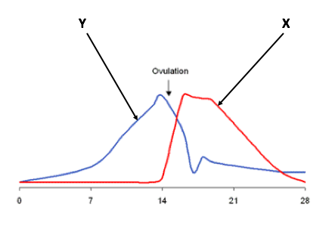

21. The line on the graph marked Y represents

(a) oestrogen.

(b) progesterone.

(c) follicle stimulating hormone.

(d) luteinising hormone.

22. The hormone marked X

(a) builds the endometrium.

(b) removes the endometrium.

(c) maintains the endometrium.

(d) stimulates the development of a new follicle.

23. Methylation of the DNA molecule

(a) enhances gene expression.

(b) inhibits gene expression.

(c) unwinds the chromatin.

(d) exposes the gene making it easier to read.

24. During oogenesis, the secondary oocyte and one polar body arise after

(a) the first meiotic division.

(b) before the formation of the primary oocyte.

(c) the second meiotic division.

(d) during the maturation phase.

25. Follicle stimulating hormone and luteinising hormone are released by the

(a) posterior pituitary gland.

(b) ovary.

(c) anterior pituitary gland.

(d) testis.

26. What name is given to the single cell that forms after fertilisation has occurred?

(a) Embryo

(b) Zygote

(c) Foetus

(d) Blastocyst

27. The primary germ layers consist of the

(a) chorion, amnion & placenta.

(b) chorion, mesoderm & endoderm.

(c) ectoderm, mesoderm & endoderm.

(d) ectoderm, amnion, endoderm.

28. Which of the following is considered a ‘lung bypass’ in a foetus before birth?

(a) Foramen ovale

(b) Ductus venosus

(c) Ductus arteriosus

(d) Umbilicus

29. Huntington’s disease is an example of

(a) autosomal recessive inheritance

(b) autosomal dominant inheritance.

(c) x-linked dominant inheritance.

(d) x-linked recessive inheritance.

30. Which of the following sexually transmitted diseases (STIs) is cause by a virus?

(a) Chlamydia

(b) Gonorrhoea

(c) Syphilis

(d) AIDS

**Section Two: Short answer 50% (100 Marks)**

This section has **ten (10)** questions. Answer **all** questions. Write your answers in the spaces provided.

Additional working space pages at the end of this Question/Answer booklet are for planning or continuing an answer. If you use these pages, indicate at the original answer, the page number it is planned/continued on and write the question number being planned/continued on the additional working space page.

Suggested working time: 90 minutes

___________________________________________________________________

**Question 31 (13 marks)**

Digestion is the process through which food is broken down into its smallest units.

Food can be broken down both mechanically and chemically so that can it can be

used to fuel the body. The structures within the digestive system allow it to carry out

this process efficiently.

The stomach is an organ of the digestive system.

(a) Explain how the stomach can both chemically and mechanically digest food. (3 marks)

________________________________________________________________________________________________________________________________________________________________________________________________________________________________________________________

(b) Bile is a fluid which is important in the digestion of fat. Describe the function of bile and explain its importance in fat digestion. (3 marks)

________________________________________________________________________________________________________________________________________________________________________________________________________________________________________________________

The small intestine is an organ of the digestive system which plays an important role

in the absorption of nutrients.

(c) Describe four (4) features of the small intestine that allow it to carry out this function efficiently. (4 marks)

________________________________________________________________________________________________________________________________________________________________________________________________________________________________________________________

______________________________________________________________

(d) Products of fat digestion are absorbed by diffusion while simple sugars and amino acids can be absorbed by active transport.

Describe three (3) differences between diffusion and active transport. (3 marks)

__________________________________________________________________________________________________________________________________________________________________________________________

______________________________________________________________

______________________________________________________________

**Question 32 (10 marks)**

Scientists at a university were investigating the effect of fluid consumption on urine output.

30 members of the university’s rugby team volunteered to be part of the study. The volunteers were all male aged 18-22 years old and all were in good health. Each volunteer signed a consent form which stated that their personal details would not be made public.

The scientists explained to the volunteers that the findings of the study would benefit their ongoing research.

During the next 5 rugby matches, 10 of the volunteers were given 1L of 100% water to drink, 10 were given a 1L of 10% salt solution to drink and 10 were given nothing to drink.

They were each asked to urinate into a container in order to measure the amount of urine produced.

(a) Write a suitable hypothesis for this investigation. (2 marks)

____________________________________________________________________________________________________________________________

(b) Identify the dependent and independent variables in this investigation. (2 marks)

Dependent variable _____________________________________________

Independent variable ____________________________________________

(c) Was the experiment valid? Justify your answer. (2 marks)

____________________________________________________________________________________________________________________________

______________________________________________________________

The table below shows the results of the investigation.

|  |  |
| --- | --- |
| **Fluid Consumed** | **Average urine output**  **(mL)** |
| Water | 520 |
| 10% Salt Solution | 370 |
| Nil | 100 |

The scientists were pleased with the results as they supported their hypothesis. They discussed the results with several friends and colleagues who had not been involved in the investigation but who knew the rugby players.

(d) Were the results gained from the experiment reliable? Justify your answer. (2 marks)

______________________________________________________________

______________________________________________________________

______________________________________________________________

(e) The scientists had endeavoured to satisfy all of the requirements of the university’s ethics committee. The ethics committee stated that the scientists had not met their standards.

Identify two (2) areas of this investigation where the scientists may have breached the university’s ethical standard. (2 marks)

______________________________________________________________ ______________________________________________________________ ______________________________________________________________

______________________________________________________________

**Question 33 (12 marks)**

A student was investigating the optimal pH conditions for enzyme action. She tested

three digestive enzymes using a variety of pH buffers. She hypothesises that each

enzyme would be most active at its optimum pH. Her results are shown the table

below.

|  |  |  |  |
| --- | --- | --- | --- |
|  | ***Enzyme Activity***  ***(arbitrary units)*** | | |
| ***pH*** | ***Pepsin*** | ***Catalase*** | ***Lipase*** |
| 1 | 7.3 | 1 | 1 |
| 2 | 9 | 2 | 1 |
| 3 | 7 | 3 | 2 |
| 4 | 4.5 | 4 | 3 |
| 5 | 3 | 5.8 | 4.2 |
| 6 | 2 | 7.3 | 5.6 |
| 7 | 1 | 9 | 7.3 |
| 8 | 1 | 7 | 9 |
| 9 | 1 | 4.5 | 7 |

(a) Use the data in the table above to construct a graph of her findings. (5 marks)

*(A spare grid is provided at the end of this Question/Answer booklet. If you need to use it, cross out this attempt.)*

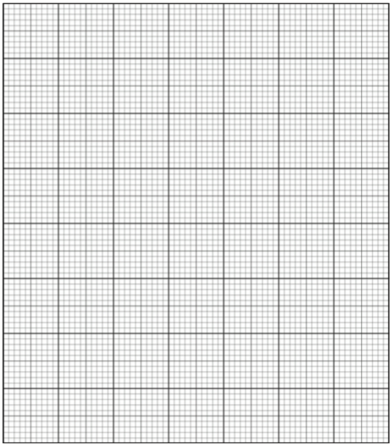

(b) Write a suitable conclusion for this investigation. (2 marks)

______________________________________________________________

______________________________________________________________

(c) The student noted that pancreatic juices contain a high concentration of bicarbonate ions. She knew that antacids also contained bicarbonate ions.

Explain the importance of bicarbonate ions in pancreatic juices. (3 marks)

______________________________________________________________ ______________________________________________________________ ______________________________________________________________

______________________________________________________________

(d) After completing her investigation, the student considered other factors that could affect the action of enzymes.

Name two (2) possible factors that she might investigate in a future experiment? (2 marks)

______________________________________________________________ ______________________________________________________________

**Question 34 (7 marks)**

The diagram below shows the main features of a nephron.

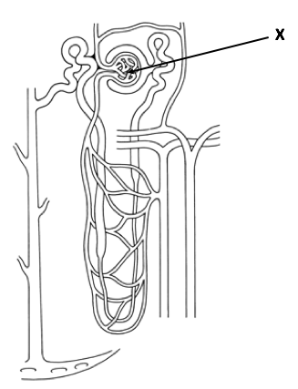

(a) Name and describe the structure marked X. Briefly outline its function. (3 marks)

______________________________________________________________ ______________________________________________________________ ______________________________________________________________

(b) Give two ways the nephrons improve efficiency by increasing surface area (2 marks)

______________________________________________________________ ______________________________________________________________

(c) The composition of glomerular filtrate and the composition of urine differ significantly.

(i) Identify one (1) substance which is present in glomerular filtrate but not normally present in urine. (1 mark)

________________________________________________________

(ii) What might the presence of this substance indicate. (1 mark)

________________________________________________________

**Question 35 (10 marks)**

All living things are made up of cells. The organelles inside our cells carry out the processes which help keep our bodies functioning.

(a) Complete the table below to correctly identify the name of the organelle or its function. (4 marks)

|  |  |
| --- | --- |
| ***Organelle*** | ***Function of organelle*** |
|  | Modification/ packaging of proteins |
| Lysosome |  |
| Mitochondria |  |
|  | Site at which amino acids are joined together to make proteins. |

(b) Cells are surrounded by a membrane.

(i) Describe the structure of the cell membrane. (3 marks)

______________________________________________________________ ______________________________________________________________ ______________________________________________________________

(ii) Outline three (3) functions of the cell membrane. (3 marks)

______________________________________________________________ ______________________________________________________________ ______________________________________________________________

**Question 36 (9 marks)**

The sketch below represents the end of a long bone.

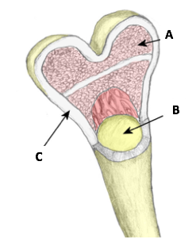

(a) Name the structures labelled A, B and C in the diagram. (3 marks)

A _____________________________________________

B _____________________________________________

C _____________________________________________

(b) Compare and contrast the structures labelled A and C. (6 marks)

______________________________________________________________ ______________________________________________________________ ______________________________________________________________ ______________________________________________________________ ______________________________________________________________ ______________________________________________________________

**Question 37 (10 marks)**

The x-rays below show two (2) types of joint found in the human body.

(a) Name the joints labelled A and B and give an example of where they might be found in the body. (4 marks)

A B

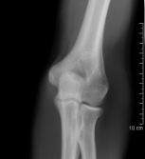 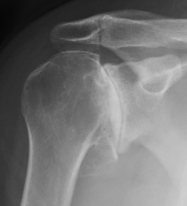

Name ________________________ ________________________

Example _____________________ ________________________

(b) Identify the type of cartilage found in the trachea. Describe its structure and its function. (3 marks)

______________________________________________________________ ______________________________________________________________ ______________________________________________________________

______________________________________________________________

______________________________________________________________

(c) Osteoarthritis is a degenerative condition of the skeletal system. The patient suffering from this condition would be in a lot of pain without medical intervention. Describe what causes the pain felt by a person with osteoarthritis and suggest an appropriate treatment. (3 marks)

______________________________________________________________ ______________________________________________________________ ______________________________________________________________

______________________________________________________________

**Question 38 (12 mark)**

The ‘Central Dogma’, which was proposed by Francis Crick in 1958, suggests that DNA is the code by which all of our proteins are produced. Crick states that DNA codes for RNA and RNA is the ‘messenger’ which leaves the nucleus. Once in the cytoplasm, RNA can become the functional proteins that we are familiar with.

(a) Compare DNA and RNA molecules. (4 marks)

______________________________________________________________ ______________________________________________________________ ______________________________________________________________ ______________________________________________________________

______________________________________________________________

(b) Outline the process of translation. (6 marks)

______________________________________________________________ ______________________________________________________________ ______________________________________________________________ ______________________________________________________________

______________________________________________________________

(c) Mitochondrial DNA (mtDNA) is unlike nuclear DNA which is inherited from both parents; mtDNA is only inherited from the mother. Explain why mtDNA is only inherited from the mother’s lineage. (2 marks)

______________________________________________________________ ______________________________________________________________

**Question 39 (7 marks)**

A couple are having their first child. The mother’s family has a history of Duchenne muscular dystrophy (DMD). DMD is a disease which causes weakening of the skeletal muscles and can lead to a premature death. DMD is an X-linked recessive condition. The mother knows that she is a carrier for this condition. The father does not have the condition.

(a) In the space below, draw a punnet square to show the chance of these new parents having a child with DMD. (2 marks)

(b) As a percentage, what is the chance that their child will have DMD. (1 mark)

______________________________________________________________

(c) After seeking the advice of a genetic counsellor, the couple decide to continue with the pregnancy and give birth to a son who does not have DMD.

What is their son’s genotype? (1 mark)

______________________________________________________________

(d) Is there a chance that their son will go on to have a child with DMD? Justify your answer. (3 marks)

______________________________________________________________

______________________________________________________________

______________________________________________________________

**Question 40 (10 marks)**

Cancer is one of the leading causes of death in Australia and affects men, woman and children.

(a) Explain how a cancerous mass forms. (2 marks)

______________________________________________________________ ______________________________________________________________

(b) Some cancers are caused by carcinogens. Give an example of a carcinogen. (1 mark)

______________________________________________________________

(c) Lifestyle choices can help prevent some types of cancer. List three ways in which a teenager can reduce their risk of developing skin cancer. (1 mark)

______________________________________________________________

______________________________________________________________

(d) Identify one type of cancer that woman are routinely screened for after the age of 40 and state the screening method that is used. (2 marks)

______________________________________________________________

______________________________________________________________

(e) Prostate cancer is most common in men over the age of 50. One of the symptoms of prostate cancer is weak flow of urine. Explain why a weak flow of urine might be experienced by men who have developed prostate cancer. (4 marks)

______________________________________________________________ ______________________________________________________________ ______________________________________________________________ ______________________________________________________________

**Section Three: Extended answer 20% (40 Marks)**

This section has **four (4)** questions. You must answer **two (2)** questions. Write your answers on the lined pages provided.

Additional working space pages at the end of this Question/Answer booklet are for planning or continuing an answer. If you use these pages, indicate at the original answer, the page number it is planned/continued on and write the question number being planned/continued on the additional working space page.

Responses could include clearly labelled diagrams with explanatory notes; lists of points with linking sentences; clearly labelled tables and graphs; and annotated flow diagrams with introductory notes.

Suggested working time: 50 minutes.

___________________________________________________________________

Answer any **two (2)** questions from Questions

**Question 41 (20 marks)**

A common theme throughout the study of human biology is the concept of surface area. Two structures that increase the surface area and hence the efficiency of the body are the villus of the small intestine and the alveoli in the lungs.

(a) Discuss the structural similarities shared by the villus and the alveoli and explain how these structures increase exchange in the lungs and the small intestine respectively. (7 marks)

(b) Red blood cells play an important role in the body. Describe the structure of red blood cells and explain why this structure allows the red blood cells to carry out their function efficiently. (6 marks)

(c) Discuss how gas exchange takes place as a red blood cell reaches the alveoli. (7 marks)

**Question 42 (20 marks)**

The production of gametes gives rise to variation within our species and helps to ensure our survival.

(a) Name and describe four (4) ways in which variation is brought about during the formation of gametes. (12 marks)

(b) Epigenetics is the study of factors that affect gene expression without changes being made to the genetic code of that organism.

Explain why the study of identical twins is important in the understanding of epigenetics. (4 marks)

(c) Embryonic stem cell research has huge potential in the treatment of human diseases. Give two (2) arguments for and two (2) arguments against embryonic stem cell research. (4 marks)

**Question 43 (20 marks)**

The musculoskeletal system consists of our muscles and bones working together in a coordinated manner to allow movement.

(a) Using the bicep and triceps as an example, explain why these muscles are referred to as antagonists and describe how they work together to bring about the movement of the radius and ulna. (8 marks)

(b) The sliding filament theory was proposed to explain the movement described in part (a) of this question on a microscopic level. Briefly describe the sliding filament theory. (5 marks)

(c) Cells must respire in order to produce a store of energy. This energy source fuels all of the processes that take place within the body.

Aerobic and anaerobic respiration are two (2) types of cellular respiration. Compare and contrast aerobic and anaerobic respiration. Include in your answer where they take place within the cell and the products produced by each process. (7 marks)

**Question 44 (20 marks)**

A woman has blocked fallopian tubes. The doctor has explained that although she has healthy eggs and her husband has healthy sperm and a healthy sperm count, the blockage will make it impossible for them to become pregnant without intervention. The doctor has suggested an assisted reproductive technology that could assist the couple in becoming pregnant.

(a) Name and describe the most likely assisted reproductive technology that the doctor suggested to the couple. Explain why this method could result in pregnancy despite the woman’s’ blocked fallopian tubes. (8 marks)

(b) Several months later, the couple are expecting their first child. She wants to do everything she can to ensure a healthy pregnancy and thus a healthy baby.

Suggest two (2) lifestyle choices that she could adopt to promote a healthy outcome from her pregnancy. You must give an explanation for the suggestion you have made. (6 marks)

(c) The woman will be monitored throughout her pregnancy to ensure that her developing baby is growing as expected.

The two (2) screening techniques that will be used are ultrasound and amniocentesis.

Describe these screening techniques and state what information can be collected on the growing foetus to show that it is developing as it should.

(6 marks)

______________________________________________________________________________________________________________________________________________________________________________________________________________________________________________________________________________________________________________________________________________________________________________________________________________________________________________________________________________________________________________________________________________________________________________________________________________________________________________________________________________________________________________________________________________________________________________________________________________________________________________________________________________________________________________________________________________________________________________________________________________________________________________________________________________________________________________________________________________________________________________________________________________________________________________________

______________________________________________________________________________________________________________________________________________________________________________________________________________________________________________________________________________________________________________________________________________________________________________________________________________________________________________________________________________________________________________________________________________________________________________________________________________________________________________________________________________________________________________________________________________________________________________________________________________________________________________________________________________________________________________________________________________________________________________________________________________________________________________________________________________________________________________________________________________________________________________________________________________________________________________________

______________________________________________________________________________________________________________________________________________________________________________________________________________________________________________________________________________________________________________________________________________________________________________________________________________________________________________________________________________________________________________________________________________________________________________________________________________________________________________________________________________________________________________________________________________________________________________________________________________________________________________________________________________________________________________________________________________________________________________________________________________________________________________________________________________________________________________________________________________________________________________________________________________________________________________________

___________________________________________________________________

______________________________________________________________________________________________________________________________________________________________________________________________________________________________________________________________________________________________________________________________________________________________________________________________________________________________________________________________________________________________________________________________________________________________________________________________________________________________________________________________________________________________________________________________________________________________________________________________________________________________________________________________________________________________________________________________________________________________________________________________________________________________________________________________________________________________________________________________________________________________________________________________________________________________________________________

______________________________________________________________________________________________________________________________________________________________________________________________________________________________________________________________________________________________________________________________________________________________________________________________________________________________________________________________________________________________________________________________________________________________________________________________________________________________________________________________________________________________________________________________________________________________________________________________________________________________________________________________________________________________________________________________________________________________________________________________________________________________________________________________________________________________________________________________________________________________________________________________________________________________________________________

______________________________________________________________________________________________________________________________________________________________________________________________________________________________________________________________________________________________________________________________________________________________________________________________________________________________________________________________________________________________________________________________________________________________________________________________________________________________________________________________________________________________________________________________________________________________________________________________________________________________________________________________________________________________________________________________________________________________________________________________________________________________________________________________________________________________________________________________________________________________________________________________________________________________________________________

_____________________________________________________________________________________________________________________________________________________________________________________________________________________________________________________________________________________________________________________________________________________________________________________________________________________________________________________________________________________________________________________________________________________________________________________________________________________________________________________________________________________________________________________________________________________________________________________________________________________________________________________________________________________________________________________________________________________________________________________________________________________________________________

_______________________________________________________________________________________________________________________________________________________________________________________________________________________________________________________________________________________________________________________________________________

______________________________________________________________________________________________________________________________________________________________________________________________________________________________________________________________________________________________________________________________________________________________________________________________________________________________________________________________________________________________________________________________________________________________________________________________________________________________________________________________________________________________________________________________________________________________________________________________________________________________________________________________________________________________________________________________________________________________________________________________________________________________________________________________________________________________________________________________________________________________________________________________________________________________________________________

______________________________________________________________________________________________________________________________________________________________________________________________________________________________________________________________________________________________________________________________________________________________________________________________________________________________________________________________________________________________________________________________________________________________________________________________________________________________________________________________________________________________________________________________________________________________________________________________________________________________________________________________________________________________________________________________________________________________________________________________________________________________________________________________________________________________________________________________________________________________________________________________________________________________________________________

______________________________________________________________________________________________________________________________________________________________________________________________________________________________________________________________________________________________________________________________________________________________________________________________________________________________________________________________________________________________________________________________________________________________________________________________________________________________________________________________________________________________________________________________________________________________________________________________________________________________________________________________________________________________________________________________________________________________________________________________________________________________________________________________________________________________________________________________________________________________________________________________________________________________________________________

___________________________________________________________________

______________________________________________________________________________________________________________________________________________________________________________________________________________________________________________________________________________________________________________________________________________________________________________________________________________________________________________________________________________________________________________________________________________________________________________________________________________________________________________________________________________________________________________________________________________________________________________________________________________________________________________________________________________________________________________________________________________________________________________________________________________________________________________________________________________________________________________________________________________________________________________________________________________________________________________________

______________________________________________________________________________________________________________________________________________________________________________________________________________________________________________________________________________________________________________________________________________________________________________________________________________________________________________________________________________________________________________________________________________________________________________________________________________________________________________________________________________________________________________________________________________________________________________________________________________________________________________________________________________________________________________________________________________________________________________________________________________________________________________________________________________________________________________________________________________________________________________________________________________________________________________________



References

Question 7- Human Heart Diagram <http://humananatomychart.us/black-and-white-heart-diagrams/> accessed 1st June 2017

Question 21- Menstrual cycle graph <https://www.thenakedscientists.com/articles/features/menstrual-cycle-and-period-problems> accessed 28th May 2017

Question 34- Nephron diagram <http://msjensen.cbs.umn.edu/webanatomy/image_database/Urinary/nephron.gif> accessed 1st June 2017

Question 36 Long bone diagram <http://www.teachpe.com/anatomy/bone_structure.php> accessed 1st June 2017

Question 37 Hinge joint <http://www.e-missions.net/cybersurgeons/?/skel_student/> accessed 2nd June 2017

Question 37 Ball and socket joint <http://shoulderarthritis.blogspot.com.au/2011/03/x-rays-in-degenerative-joint-disease.html> accessed 2nd June 2017